**Section 1: Nested if-else Statements**

Q1

Code: 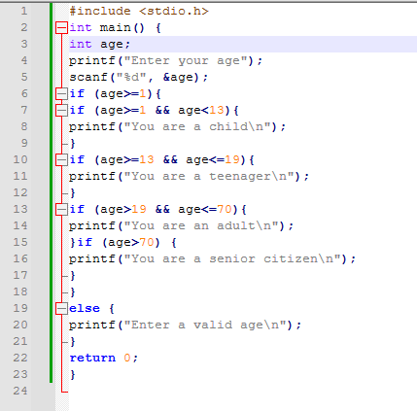  
Output: 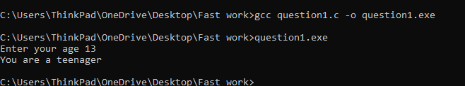

Q2

Code: 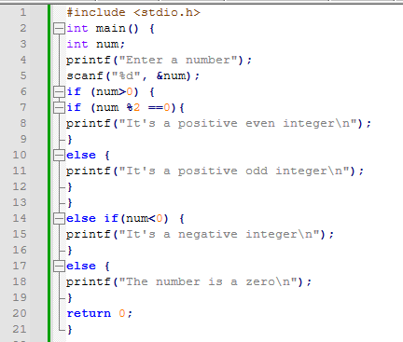

Output: 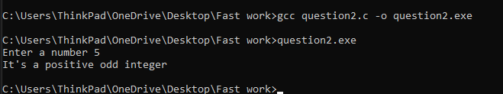

**Section 2: Logical Operators**

Q1

Code: 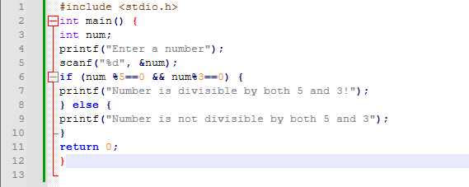

Output:

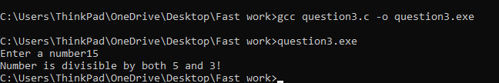

Q2

Code: 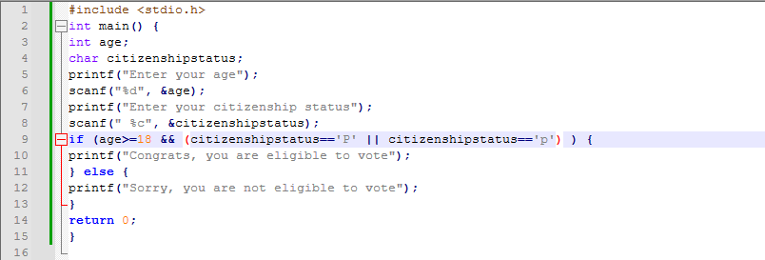

Output: 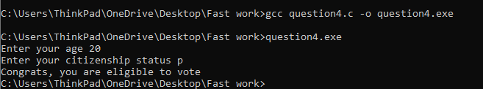

**Ternary Operators:**

Q1 Write a program using a ternary operator to find the maximum of two numbers.

Code: 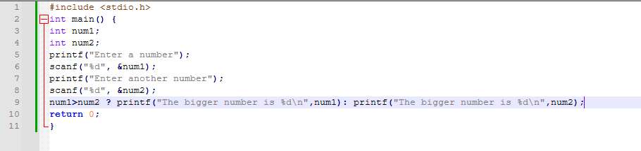

Output: 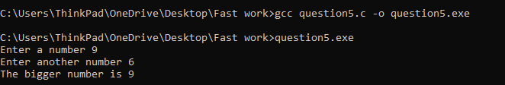

**Question 2:**

Code:

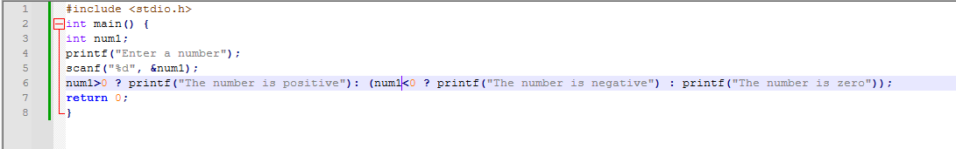

Output:

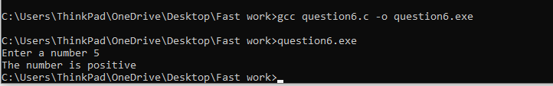

**Bitwise operators:**

**Q1:**

Code: 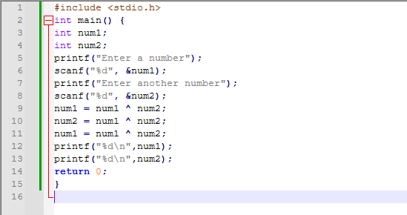

Output:

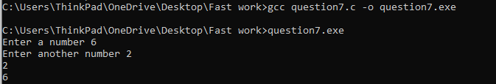

**Modulus Operator**

Q1

Code:

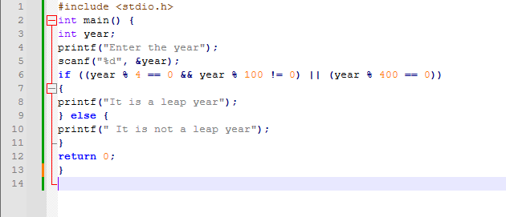

Output:

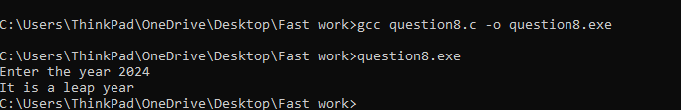

**More problems:**

Q1

Code:

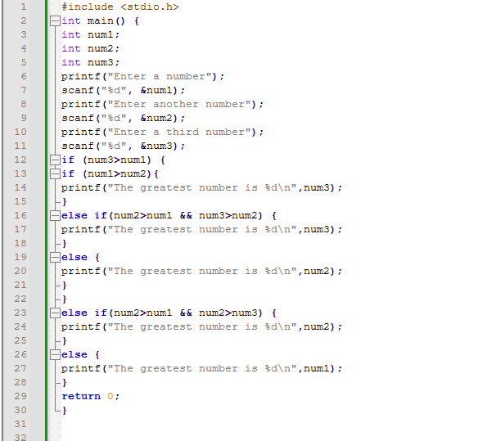

Output: 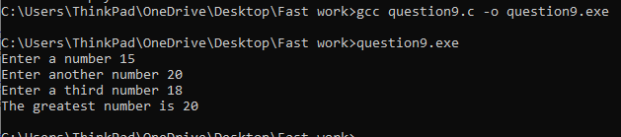

Q2:

Code:

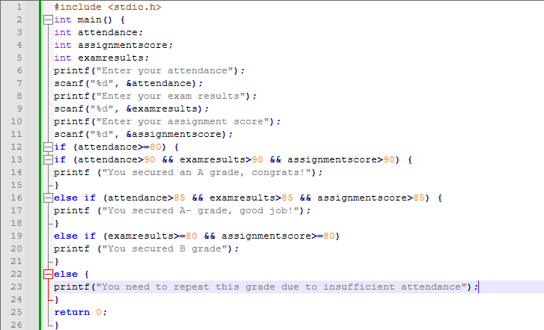

Output:

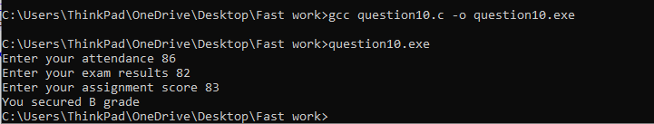

Q3

Code:

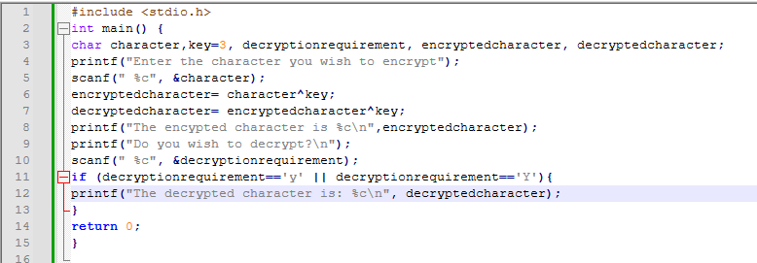

Output:

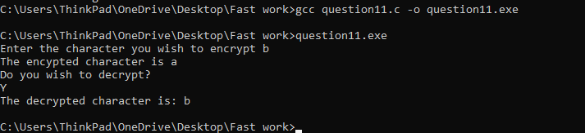

Q4

Code:

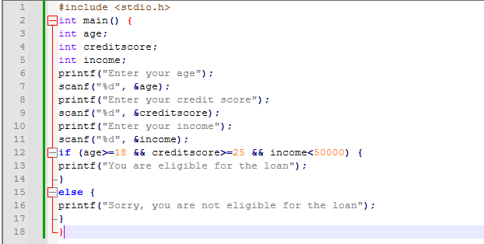

Output:

